**Basic Postgres SQL :** is a db we use to store the information and retrieve the information.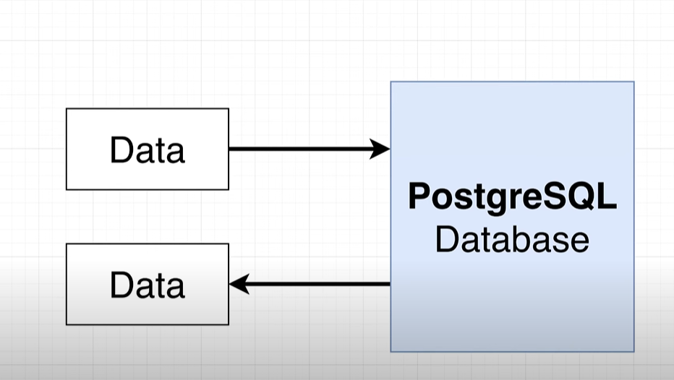

**# To work with postgres we connect to client,** client can we utility server or a program which access and store the data with some purpose.  **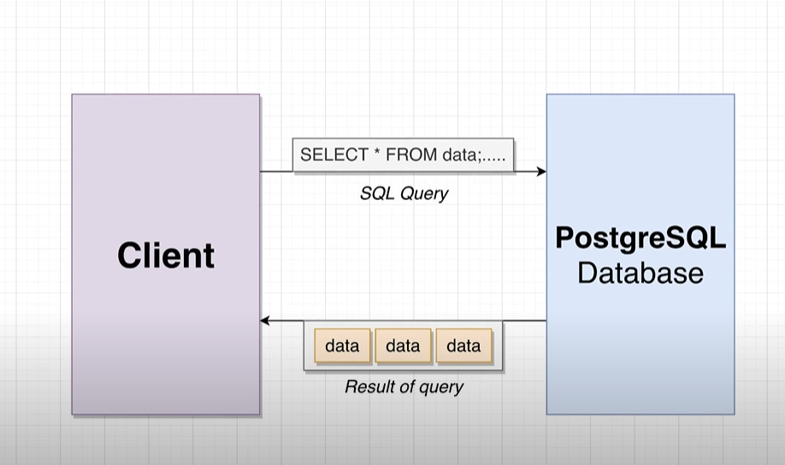  
# we connect client to db using SQL(STRUCTURED QUERY LANG):  
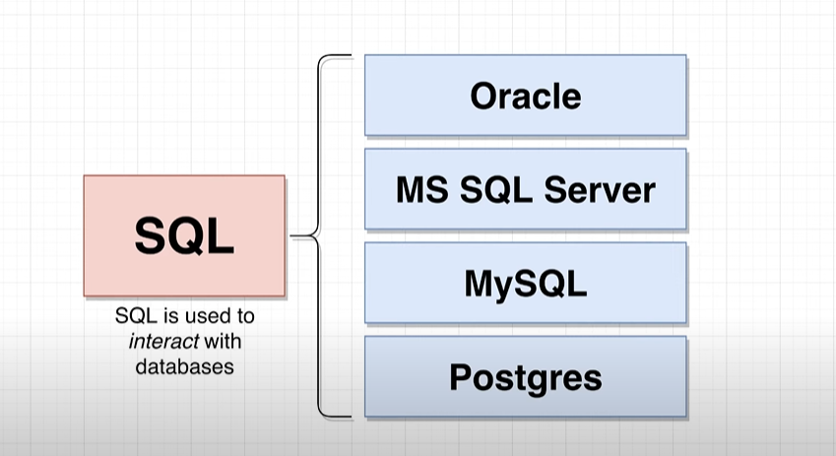  
  
Note :** we use SET in postgres to update the data into db.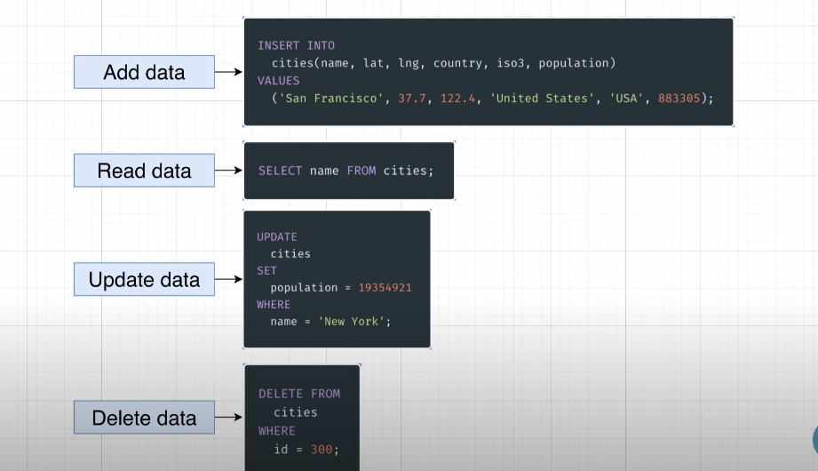  
# when u write the query think following point 1st for facing challenges:  
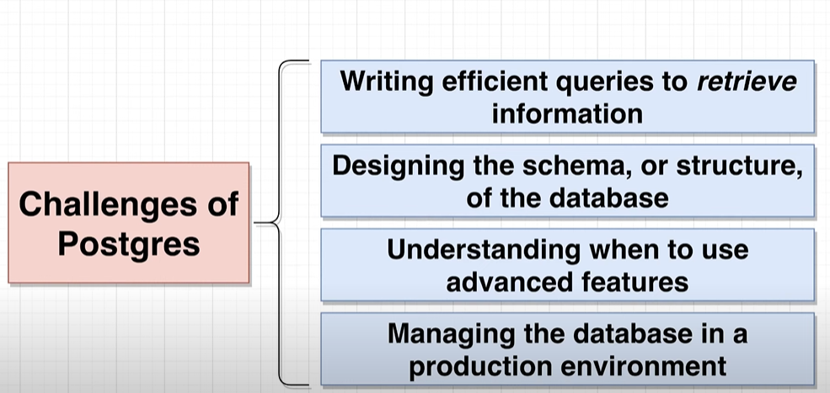  
Here we will focus on 2 challenges :

1. Writing efficient query.
2. Designing the structure of the db.

**# Before designing the db we follow the following process:  
  
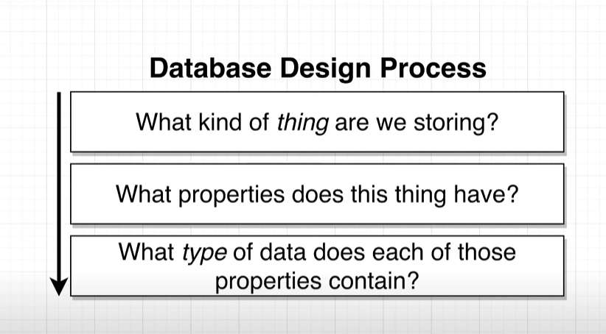  
assume here we are taking example of populated city in the world:  
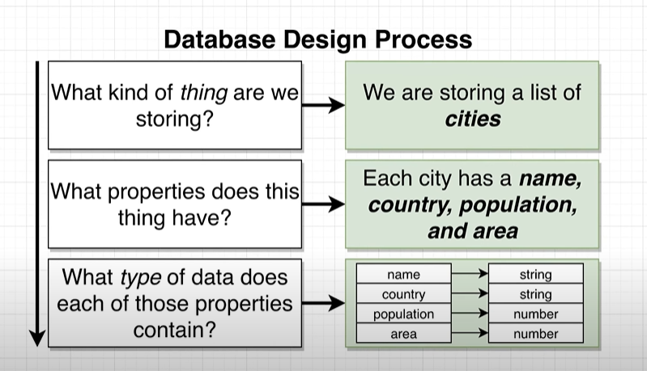  
Than we should think in this way:  
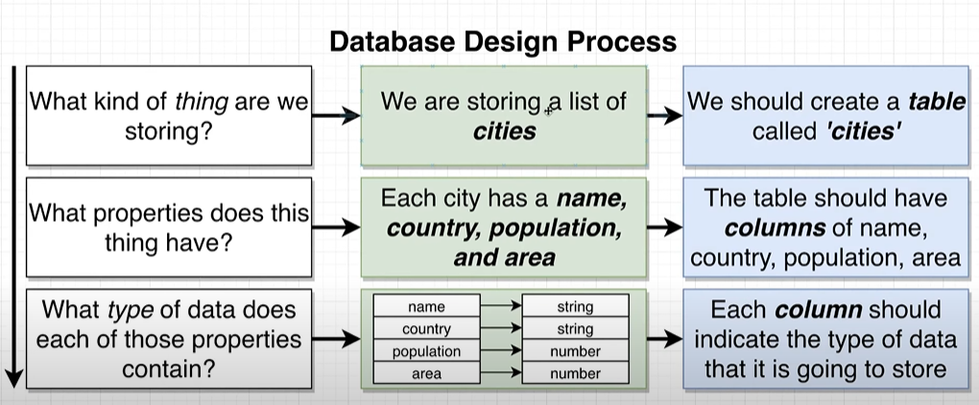  
than we create a table like following:  
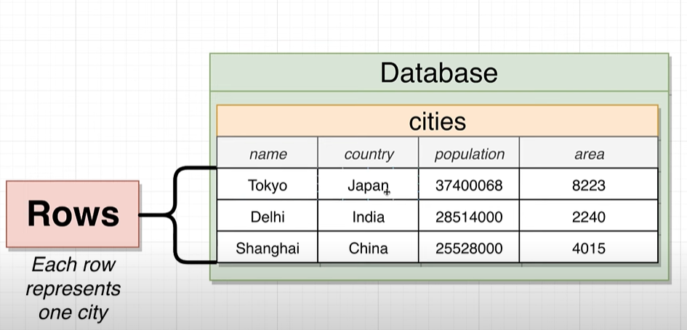  
Now, we will write the query to create a table:**   
CREATE TABLE cities(  
name VARCHAR(50),

Country VARCHAR(50),

Population INTEGER,

Area INTEGER  
); **After running this query following structre will going to create in ur db:  
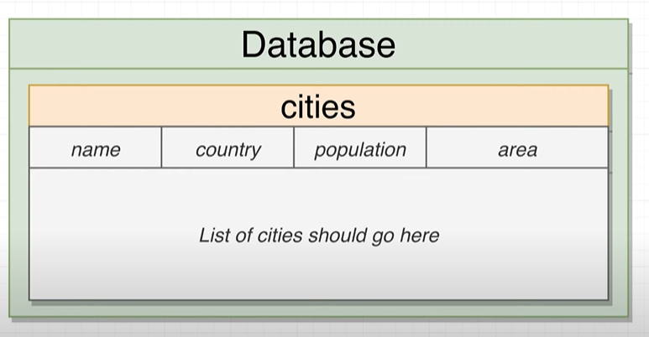**

**Note:  
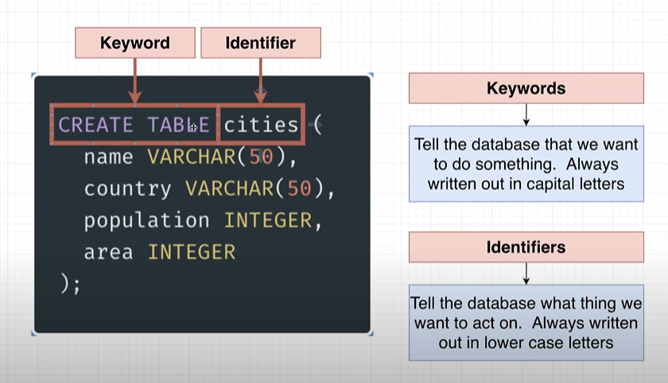  
Now will insert the value into the table:**INSERT INTO cities (name,Country,Population,Area)

VALUES ('begaluru','india',45783783,6876);

Inset multiple rows in single column:

INSERT INTO cities (name,Country,Population,Area)

VALUES ('begaluru','india',45783783,6876),

('tokyo','japan' ,773783,676),

('shanghai','china',6783783,66876),

('Soa_Paul','Brazil',5483783,23876);

To directly fetch the data from the table we can use :  
 SELECT * FROM cities;

If u want specific column than :

SELECT name , Country FROM cities;

# Except pulling data we can perform operation and transform the data before we retrieve, for example I want the density of the city per square km so:

Density= population/area

SELECT name , Population/Area AS Density FROM cities;

# Same like that we can filter the query result :  
 SELECT name , Country FROM cities where area>4000;  
 it execute in following way:  
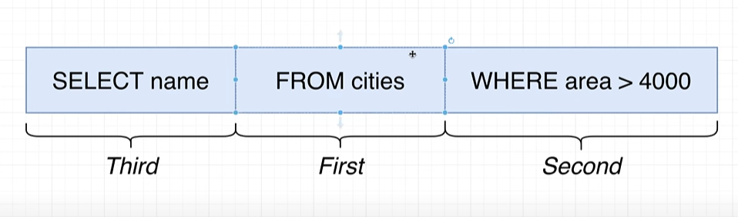  
Some operator we use with where:

SELECT name , Country FROM cities where area>700;

SELECT name , Country FROM cities where area BETWEEN 100 and 4000;

SELECT name , Country FROM cities where area IN (600,66876,6876);

SELECT name , Country FROM cities where area NOT IN (600,66876,6876);

Note: In between oprerator it included the value as well to check.

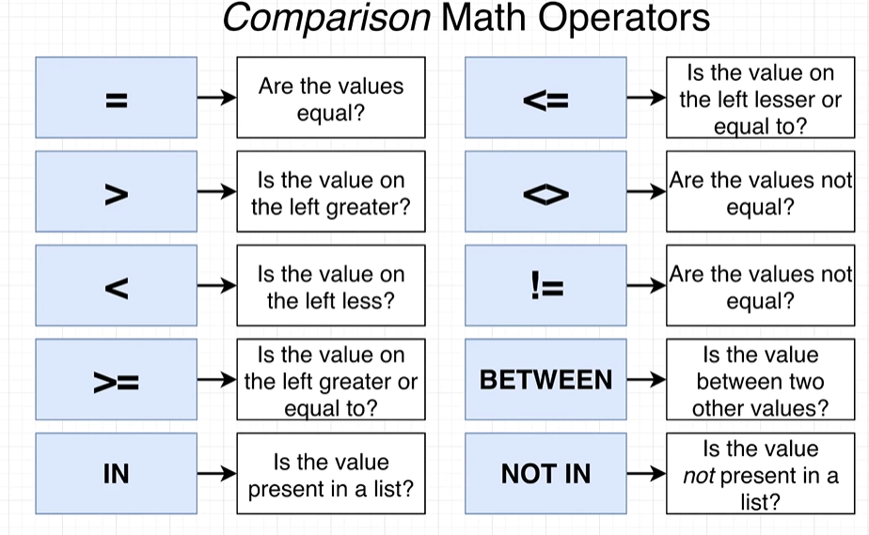

Note: If u try with following way it will give u a error:  
 SELECT name , Population/Area AS density FROM cities WHERE density>6000; because

density is not a column in the table.

SELECT name , Population/Area AS density FROM cities WHERE Population/Area >6000;

Is a correct way.

#**Now we will use the update to update the existing data into the table:  
 UPDATE cities**

**SET Population = 39550500**

**WHERE name = 'Tokyo';**

**Delete keyword:  
 DELETE** FROM **cities WHERE name =’tokyo’;**

IN Reality we have many table in one db like following :  
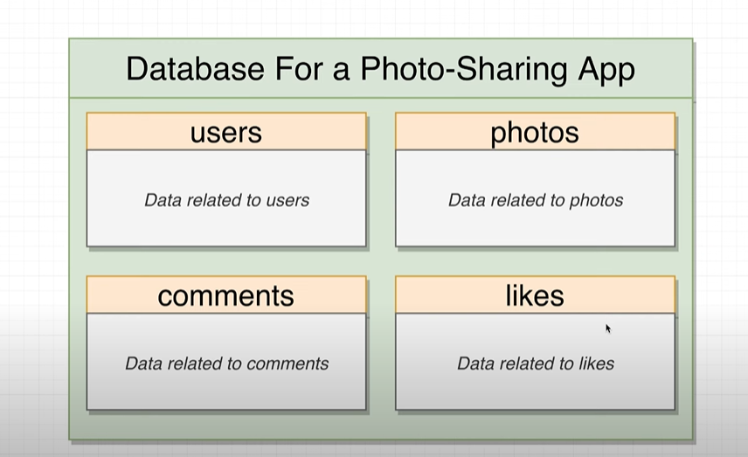  
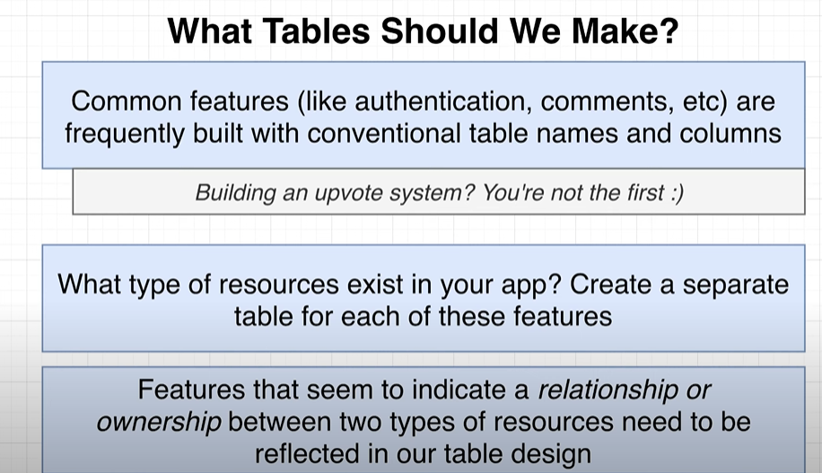  
Lets take a example of insta where we have many sections, this is the user profile page :  
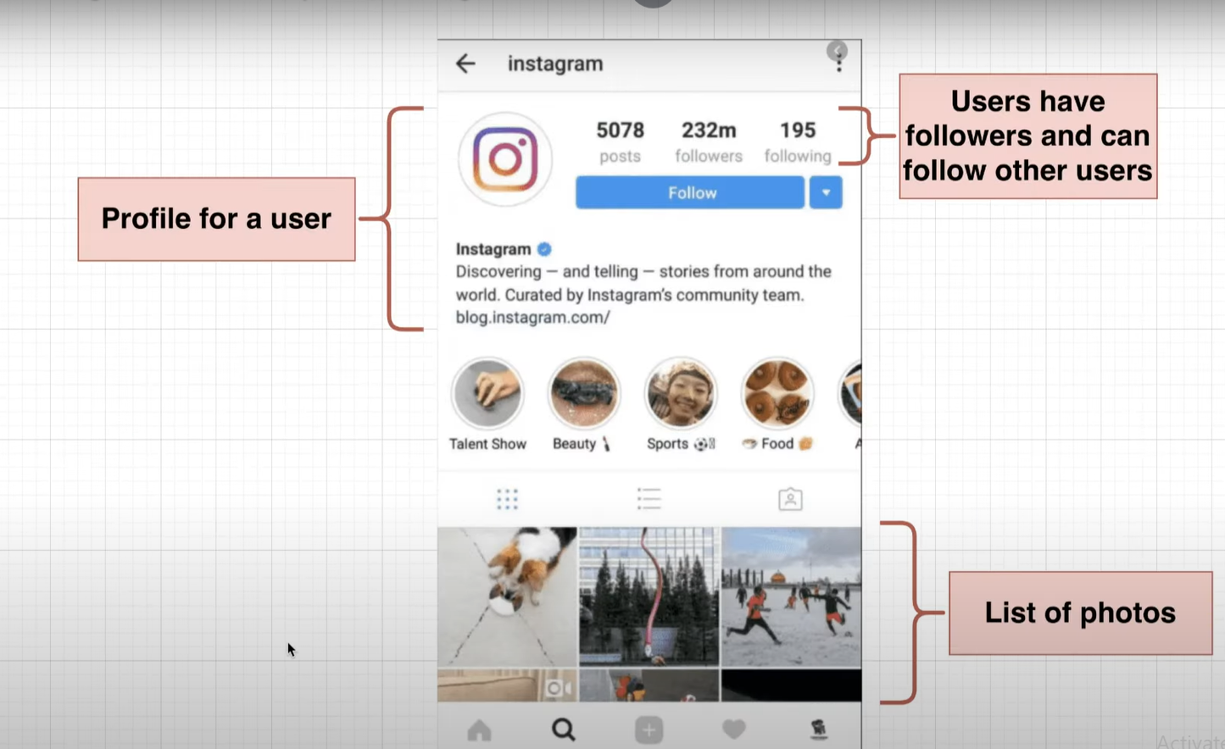  
Here in comman page we have some post on it:  
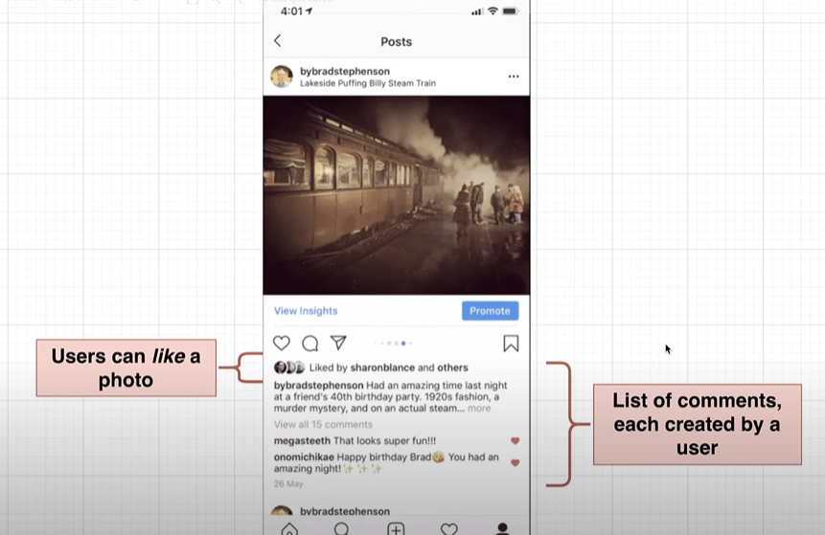  
**From there we can understand there is a relationship between users and there comments:  
In RDBM we have 4 type of relationship:  
 1. 1:1 (one to one)  
 2. 1:M(one to many )**

**3.M:M (many to many).  
4.M:1 (many to one)  
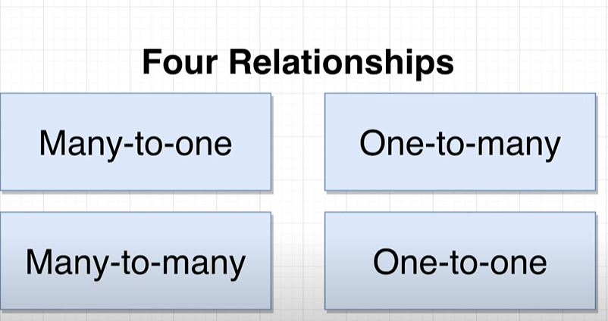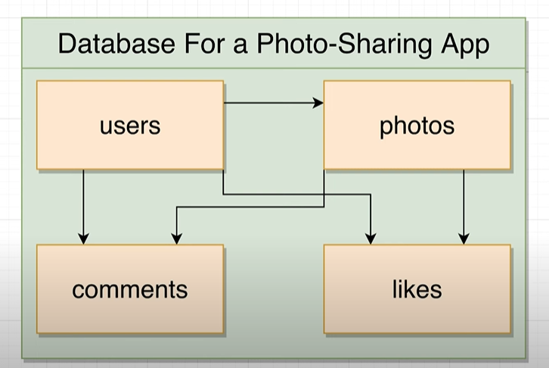 One to one relationship(1:1):**

**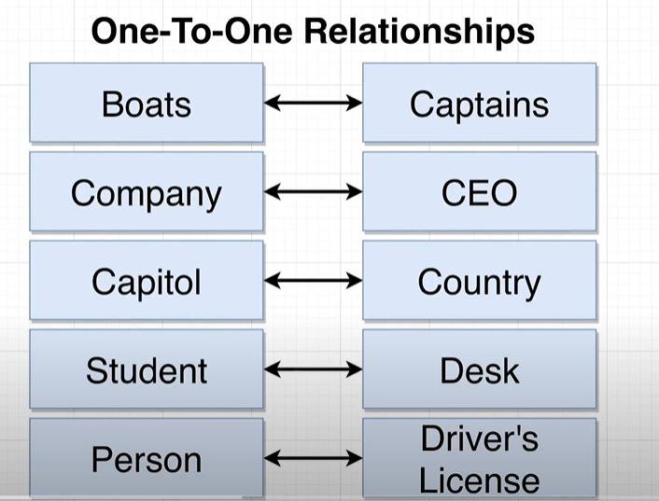  
  
One to many relationship 1:M:🡪 has one**one insta user can post mant photos.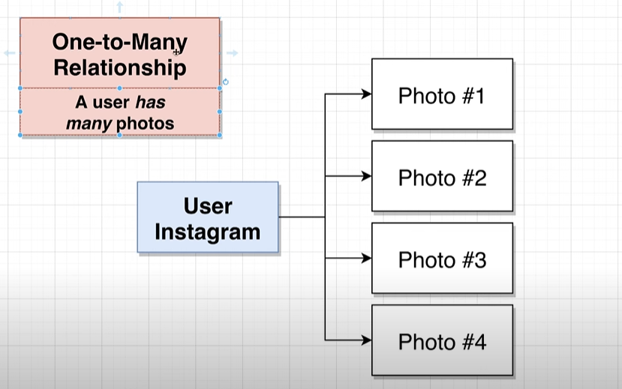  
**Many to one (M:1): 🡪 Has Many**one photo has many comment.  
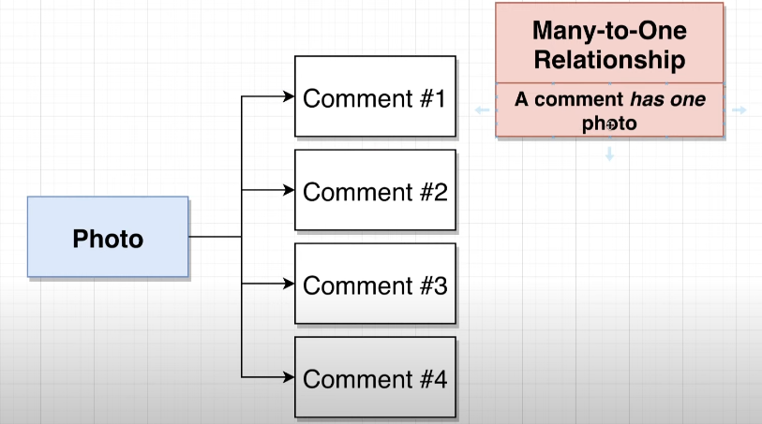  
 Note: One to many and many to one both are vise versa only perspective we have to change.  
 1:M <-> M:1  
  
# Many to many relationship M:M:  
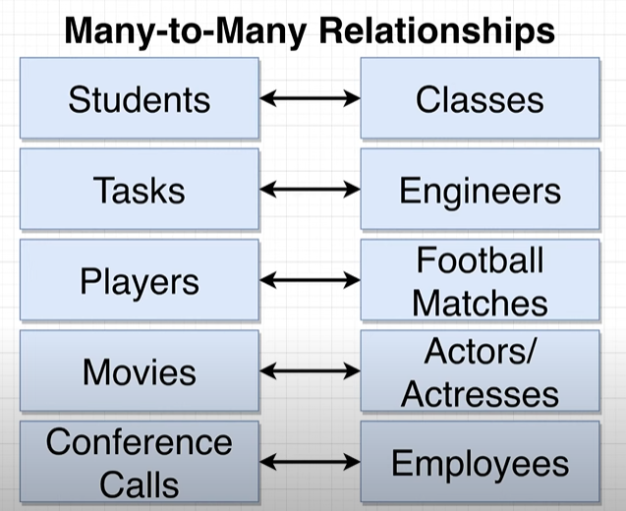  
Note: To set the relationship between table we have following keys:  
1.Primary keys(Unique row and not null)  
2. Foreign key (foreign key can be null)  
we relate the relationship between foreignkey and primany key of another table.  
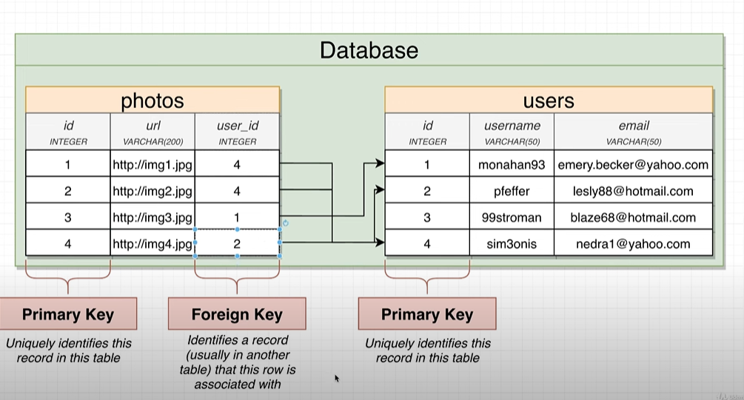

# many side of the table get the foreign key table :  
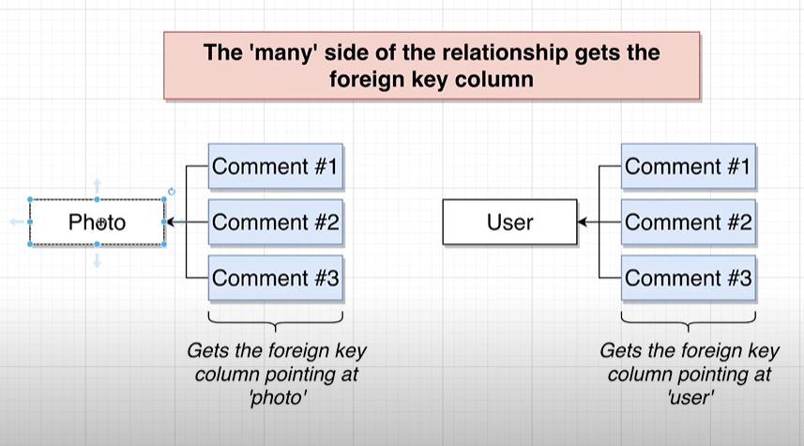  
Example:

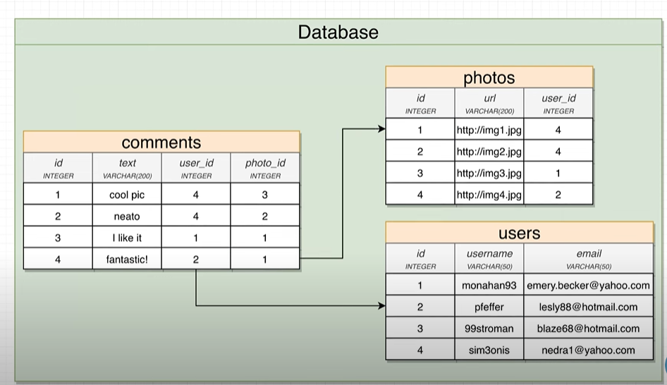  
Note: difference between foreign and primary key:  
